1-2 Robot – Status report 3
Kevin GAITAN FIGUEROA
Ernesto RINCON MARQUEZ

Progress

Low-level software
- Finished low-level motor_state node structure and logic
  - We found out that the Dynamixel SDK library presents the same limitation as Dynamixel Workbench when trying to read the status of two different types of motors at the same time. We were able to work around this by dividing the commands by type of motor
  - The node subscribes to the /motor_cmd topic and sends commands to the Dynamixels.
  - It also reads the status of all 4 motors and sends them to /motor_states, which is then read by the user’s workstation
  - We are currently working on ironing details such as data types and unit conversions between the motors and the ROS nodes
- Calibrated orientation motors’ zero position
- Configured orientation motors to spin in reverse direction to match the kinematic model, as they are mounted upside down
- Tested various integration scenarios (Low-level ↔ GUI)

High-level software
- Finished sim and real_world nodes
  - We made sure to decouple them from the GUI so that they can be ran independently
- Completed QT GUI which can be used to launch and send commands to sim and real_world nodes
- Refined URDF model to a more accurate representation of the robot
- Created skeleton controller node
  - This node implements the suggested point tracking using linearizing outputs with a static feedback proportional control law
  - Further testing is required as currently the robot presents undesired behaviors in the simulation
- Separated the high and low-level code in different ROS packages (mobile_robot for the Raspberry Pi and workstation for the computer running the GUI) this avoids dependencies problems in the RPi due to the GUI.

RQT Graph of the end to end integration:
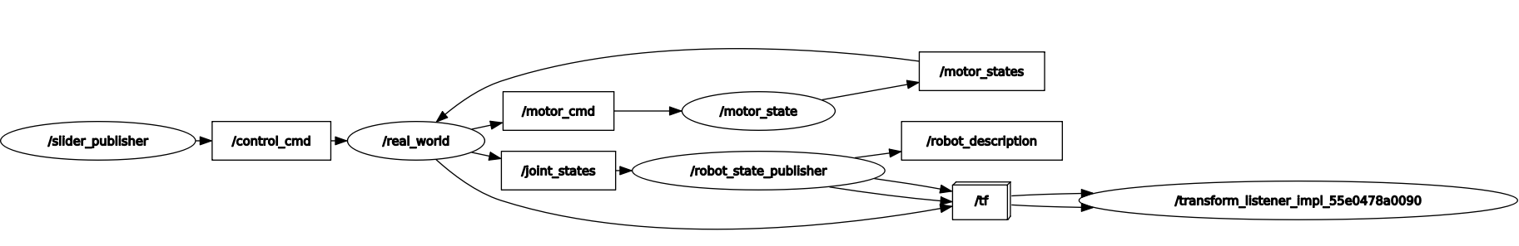

Next steps
- Continue testing controller node in simulation
- Finish unit conversion and cleaning motor_state node
- Testing full integration and bug fixing
- Dynamic model calculation
- Torque control

